**Class Exercise – 5.2**

**Name: Patrick Woodrum**

**Clemson ID: C79975506**

**Submission**: Save this Word document with your answers as a PDF file and upload the PDF file to Canvas.

**Kitchen Gadgets**

Kitchen Gadgets sells a line of high-quality kitchen utensils and gadgets. When customers place orders on the company’s Web site or through electronic data interchange (EDI), the system checks to see if the items are in stock, issues a status message to the customer, and generates a shipping order to the warehouse, which fills the order. When the order is shipped, the customer is billed. The system also produces various reports.

Use one of the diagramming tools identified on the “External Tools Page” in Canvas.   
You’ll need such a tool for this chapter’s case study.

**Tasks**

1. List the 3 External Entities described above
   1. Customers
   2. Warehouse
   3. Web Site/EDI
2. Draw a context diagram for the order system.

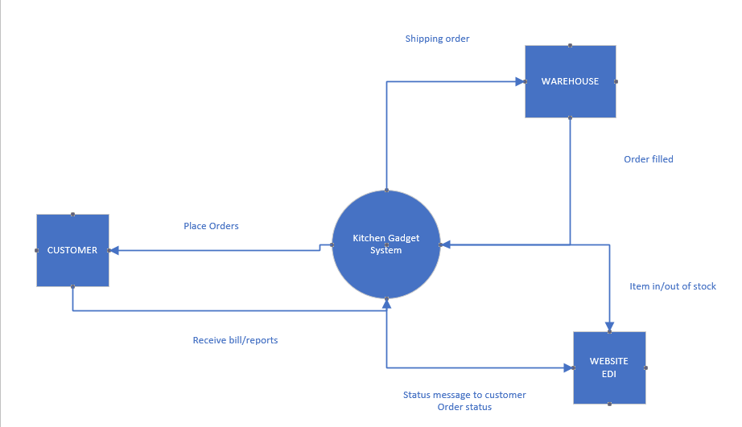

1. Draw a diagram 0 DFD for the order system.

